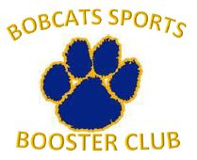
Sports Booster Club Meeting
Thursday, November 15, 2018
Cancelled due to bad weather. Agenda items discussed at executive board meeting held on 11/26/2018.

6:00 – 7:30pm
High School Cafeteria

AGENDA
Note Taker:
Time Keeper:
Present:

 | Agenda Item/Notes: | Action/Notes:
 | Introductions
 | Approval of October 2018 minutes
Athletic News & Updates
- Team Representative Updates
- News from Athletic Dept
 | New membership acknowledgements
Old Business:
- Club Correspondence
New Business:
- Treasurer report
- Concessions Updates -- WINTER
- Club objectives for year including goals for partnership with athletics department
- Hall of Fame – Nov. 24
- Graduation Awards Definition and Selection Procedure
- Marketing & Webstore.
 | Funding Requests
 | Open for discussion/suggestions
 | Next Meeting: December 20, 2018
 | Adjourn
*If time allows

