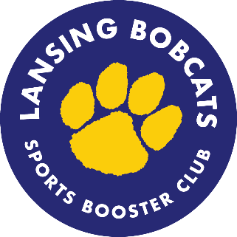
Sports Booster Club Meeting
Thursday, January 21, 2021
Meeting via Zoom
6-7pm

Meeting Notes
Note Taker: Davina Desnoes
Time Keeper: 6:00pm – 6:33pm
Present:
Kelly Bell, Debbie Crandall, Lori Crandall, Brett Hotchkiss, Debra Huber-Hwang, Margaret Shackell
Officers: Deb Bell, Davina Desnoes, Billie Downs, Becca Lovenheim

Members and Guests

 |  | Agenda Item
1. |  | Approved minutes from 2/20, 5/20, 11/20 and 12/20 (6/20 was e-board meeting)
2. |  | Athletic Department Updates  - Workouts for basketball and indoor track. Wresting is doing conditioning. No anticipated competition for these sports and practices will be held 1/19-2/11.  - Boys varsity swim and bowling seasons officially started on 1/4. All of their meets/matches are virtual using their home pools and then times are compared. The journalism class is working to have a live feed from some of the swim meets. Bowling had their first match on 1/12 and swim team’s opener is scheduled for 1/19.  - Athletes can go to weight room on their off day from practice with limited capacity and following protocols. Starting off with boys and then will add girls the following week.  - Fall 2 season to begin on March 1st.  - Spring sports are moving ahead on a consolidated schedule.  - A camera has been installed in the gym and a YouTube channel will be used to view athletic events.  - Athletic department is supportive in coordinating coaches to help get information out to seniors. May also try to do a uniformed photo shoot for seniors.  - We need an advocate to do outreach for younger athletes, especially to middle school students and freshman in terms of what to expect for next fall. More important for those who did not have any athletic opportunities since March of last year.
3. |  | Treasurer’s Report  - Not a lot of activity.  - Varsity girls soccer jackets and pinnies ordered.  - Received $1,000 for coach’s fund from Daryl and Phyllis Hanor Foundation to be reflected in January treasurer report.
4. |  | Membership  - Notice went out to Junior class about memberships and received a few follow ups. Free for this year and if you sign up for this year you will receive a free year next year. Athletics will not be penalized if they were not able to play their sport.  - Will sent out reminders once a month that membership is free via PTSO newsletters and along with webstore is always open. Membership are based on family household.
5. |  | Webstore Updates  - No sales in January. Looking to advertise new items so that members know and keep up with the store.  - Once COVID is over – would like to start up the Bobcat gear share collection.
6. |  | Yearbook Ad: Review and select final design  - Christine Maloney helped design a yearbook ad. The Ad is due before our next meeting.  - Reviewed 2 ad options and voted on the second one with the varsity blue font. Cost will show up in our next month’s financials.  - We will give Christine a bobcat umbrella as a thank you.
8. |  | Other suggestions/input:  - Please continue to reach out to Sport Boosters for any questions/suggestions.  - Matt Loveless has been wonderful and open with listening.
9. |  | Next meeting: February 25 (NOT 2/18 due to school vacation)

